Deploying the eRegistrations stack

eRegistrations stack runs in a docker environment. To generate the configuration files needed for the containers to start, we will be using a script that will:
- Generate the docker-compose.yml file bases on the options chosen
- Generate an environment file
- Generate the webserver configuration files
- Pull the needed docker images
- Startup the docker container
- Start the webserver

- Ensure privileged deployment user:
sudo adduser jenkins
sudo passwd -d jenkins
sudo usermod -aG sudo,docker jenkins
sudo su - jenkins

- Generate key pair for granting access to Bitbucket or similar https://bitbucket.org/unctad/eregistrations/admin/access-keys/
ssh-keygen -t ecdsa -b 256
cat ~/.ssh/id_ecdsa.pub

- Create workspace for running setup scripts
cd /opt
sudo mkdir eregistrations
sudo chown -R jenkins:jenkins eregistrations
git clone https://bitbucket.org/unctad/eregistrations-starter-conf.git eregistrations
cd /opt/eregistrations/scripts/
sudo pip3 install -r requirements.txt

- Generate random passwords & set up environment variables
sudo python3 deploy.py # pwd
sudo python3 deploy.py # auth
cd /opt/eregistrations/compose/eregistrations/
nano .env

- Allow helper scripts to pull up the whole stack
cd /opt/eregistrations/scripts/
sudo python3 deploy.py # all

- If local translations service wasn’t set up, ensure both-sided access to our testing instance:
sudo ufw allow from 88.99.186.246 to any port 61613
curl -s https://api.ipify.org # Register this on our side

- Connect to the mongo interface, authenticate with eregistration user (the password can be found in the .env file under RESTHEART_MONGO_DB_PASSWORD variable
mongosh
use admin
db.auth('eregistration','YOUR_PASS')
use eregsystem
db.jenkins.insertOne({'_id':'deploys'})

- Visit https://login.YOUR_DOMAIN_NAME and import keycloak-realm.json that deploy.pt ‘auth’ step generated, add any users as admin if you wish to avoid traditional sign-up flows
- Visit https://bpa.YOUR_DOMAIN_NAME, configure languages & currencies, pull translations, optionally set up a simple test service to verify the stack works, payment providers’ listing update requires a restart of bpa-backend
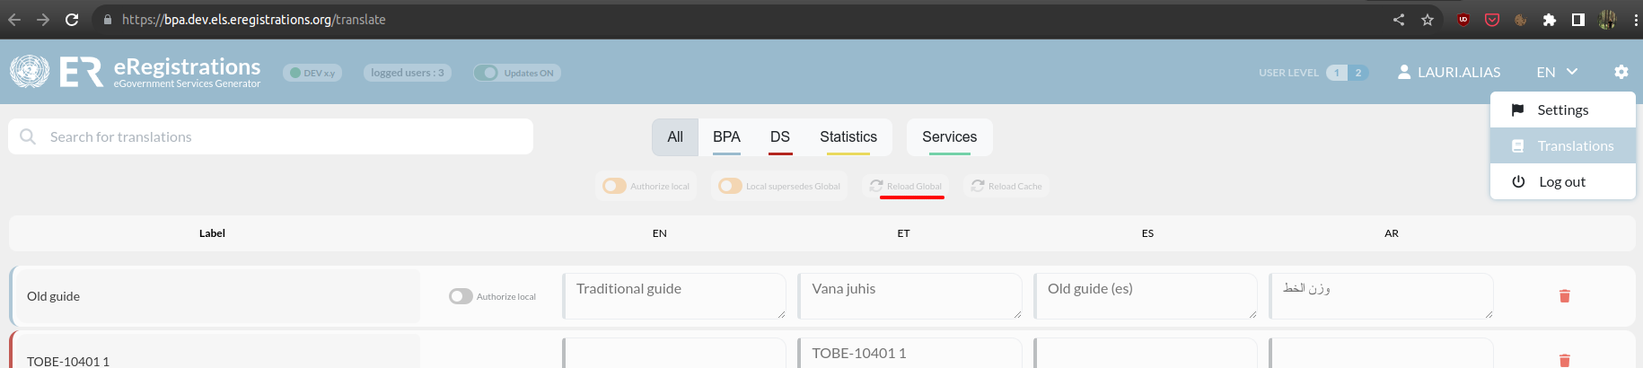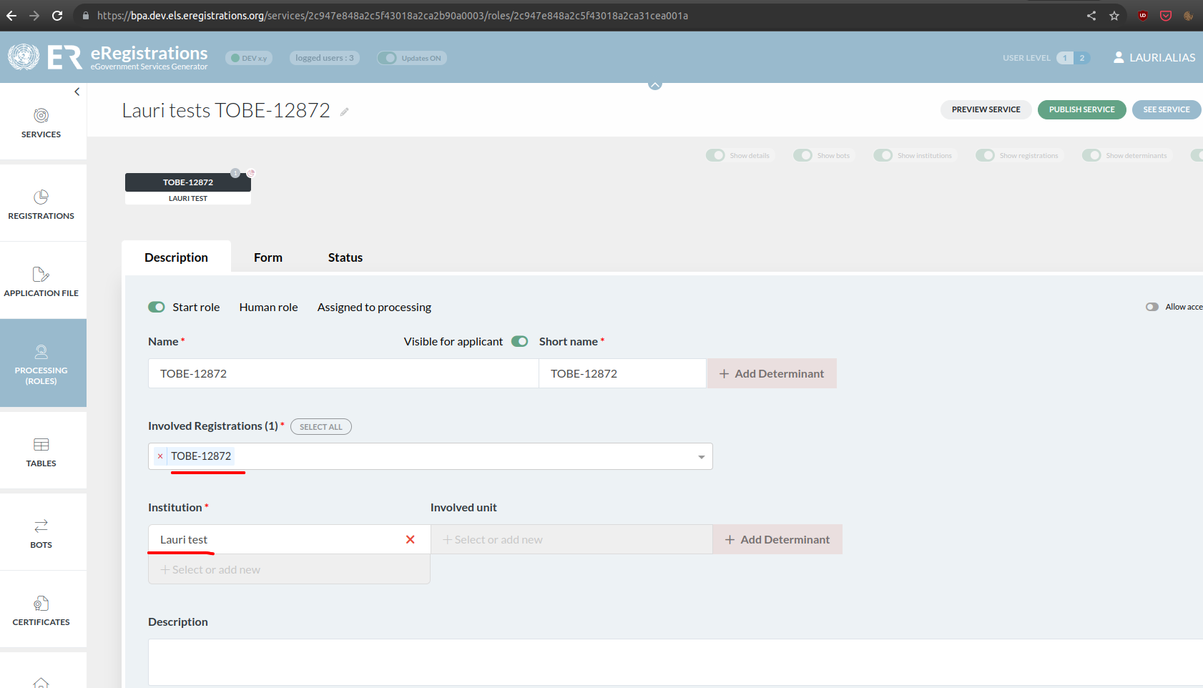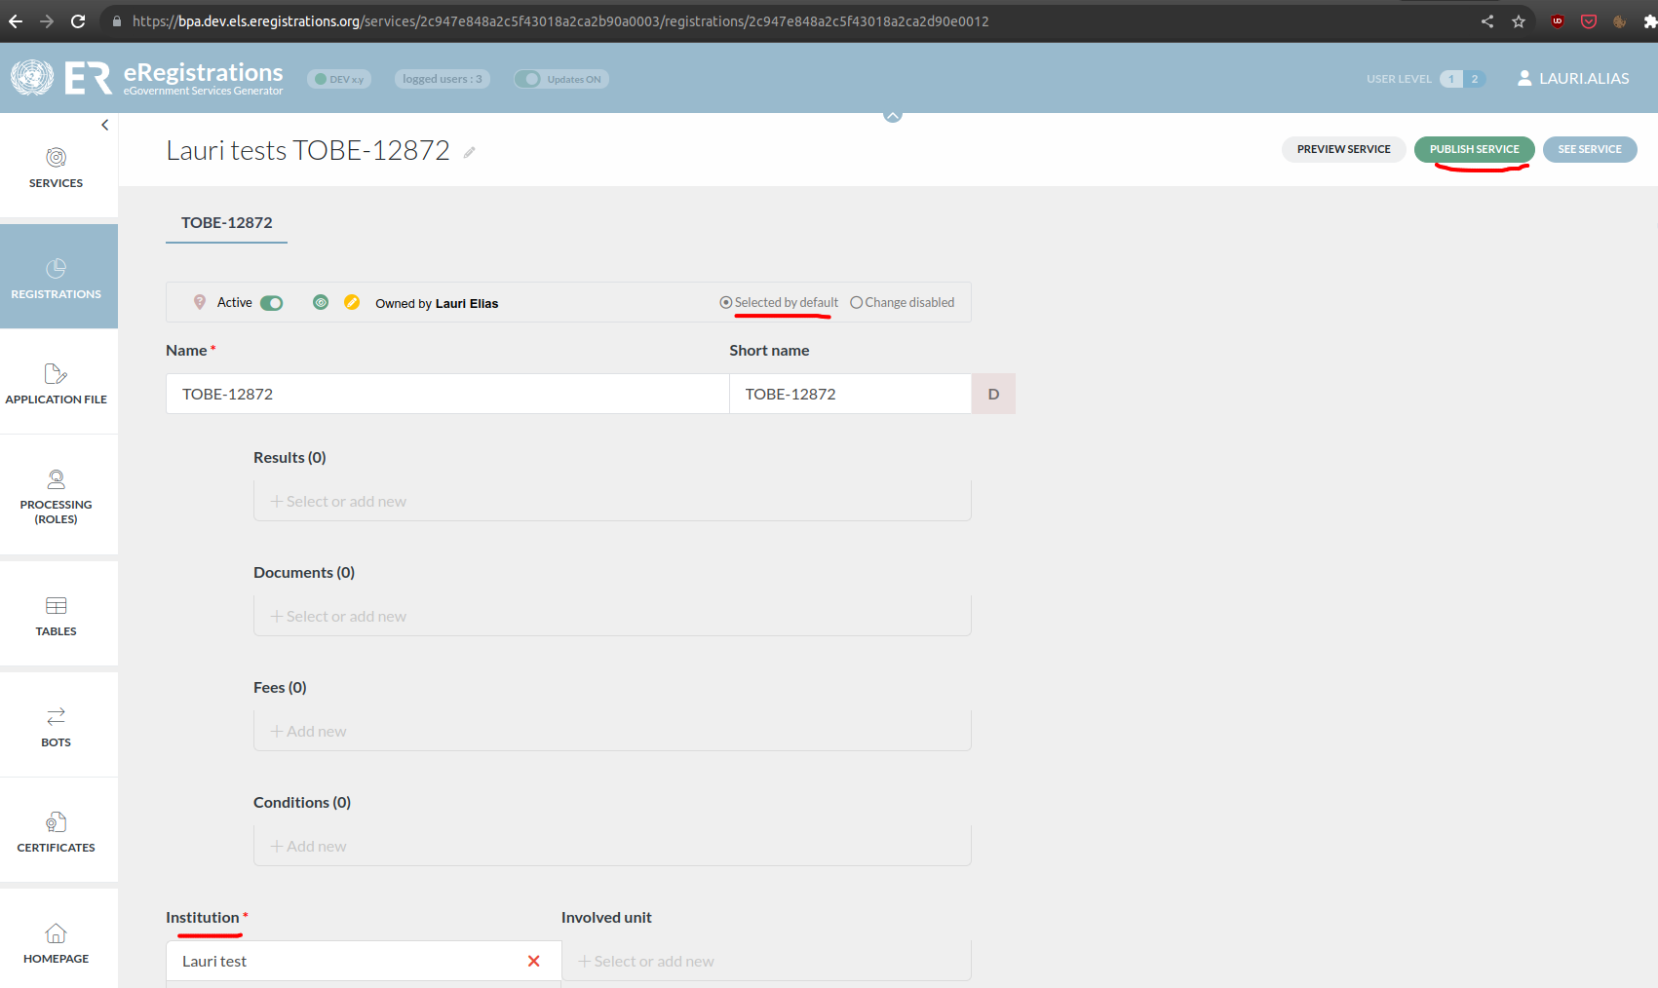
- Optionally persist the generated docker-compose.yml, .env in some other location

